Bridging the Digital Divide: The Role of Public Libraries

Chiantia D. Sago

[Chiantia.Sago@usm.edu](mailto:Chiantia.Sago@usm.edu)

College of Library and Information Science

University of Southern Mississippi

LIS 651 H002: Fundamentals of Information Science

Dr. Jeff Hirschy, Ph.D., Assistant Professor

November 9, 2022

# Abstract

This study aims to determine how much researchers studied digital literacy and the digital divide before the pandemic concerning the role of public libraries. This study analyzes research conducted on the digital divide and digital literacy before and after the COVID-19 pandemic. A literature review discussed influential research that attempts to define the digital divide, digital literacy, and the public libraries' role in the digital age. This study will determine whether sufficient research was available to prepare public libraries for the onslaught of the pandemic based on the number of articles produced before 2020. The second purpose of this study is to explore whether there is enough research on public libraries' role in bridging the digital divide and assessing the prevalence of digital literacy research.

*Keywords:* Digital divide, digital literacy, digital equity, digital inclusion, digital exclusion, internet access, information, digital devices, information literacy, libraries, librarians, United States, broadband, broadband equity, digital redlining, digital foundation skills, broadband adoption.

Introduction

New problems created new phases of the digital divide, constantly evolving its meaning. In the early 1990s, the digital divide emerged as "an uneven distribution of Internet access" (van Deursen & van Dijk, 2013). However, its basic technological infrastructure has evolved to include hardware (computers, smartphones.), software (Windows, Mac, apps), and Internet access. The most common definition of the digital divide is "*a division between people who have access and use of digital media and those who do not”* (Dijk, 2020, p. 1). Jan van Dijk (2020) notes that several U.S. newspapers first used the term *digital divide* in 1995, but there needed to be a clear explanation of its meaning. Other terms were used before the digital divide became a working concept. Most terms concerned the “concepts of information society and (in)equality: information inequality, knowledge gap, and participation in the information society” (Dijk, 2020). At the same time, “access and use became linked to digital skills or literacy, [and] motivation” (Dijk, 2020).

Historically, in 2001, Pippa Norris authored “the first frequently cited scientific book about the digital divide” (Dijk, 2020, p.7), and she made distinctions between a global, social, and democratic divide (Dijk, 2020). Norris reported that the global divide refers to industrialized and developing countries, the social divide refers to high-to-low-income populations, and the democratic divide refers to “people who use and do not use Internet resources for community engagement” (Dijk, 2020). Primarily, van Dijk (2020) stated that Norris believed the digital divide was a matter of physical possession of a computer and an internet connection.

The evolution of research on the digital divide diverged the concept into three phases or levels: the first level focuses on physical access, the second level focuses on skills and usage, and the third level focuses on outcomes (Dijk, 2020, pp. 7-14). "The first phase of discourse and research was marked by a rapid uptake of computer possession and Internet connections among the general population" (Dijk, 2020, p.8). The uptick began in the United States when less than 30% of Americans owned a computer, and only 20% possessed a modem by 1995 (Dijk, 2020). However, the percentage rose by more than 20 percent by 2001, "the figure was 56% for computers and 50% for the Internet" (Dijk, 2020). As computer and Internet possession rates increased, so did the apertures. Compared with people with low education, income, or employment, seniors, and ethnic minorities in a country between 1995 and 2004, those with higher education, income, employment, the young, and the majority ethnicity had a higher adoption rate of computers and Internet connections. (Dijk, 2020).

Strover (2019) states that the library is the most inclusive public institution. A library serves as a 'safe space' for gathering information. For a long time, libraries have also offered "all-inclusive information services, such as audio and braille books" (Beyene, 2018). “The advent of digital technology has created favorable grounds for pursuing the ideals of all-inclusive information services” (Beyene, 2018). As the equalizer of resources, libraries established themselves as the social agent of community development among these demographics because they “embody social values of tolerance and equality and operate as a sort of civic meeting ground” (Strover, 2019). According to Strover (2019), “generally lacking citizenship, gender, age, race, and ethnicity barriers to entry, libraries have been among the most transparent and welcoming of civic institutions.”

Approximately 42 million Americans lack access to affordable, high-quality Internet (*Recommendations and best practices to prevent digital discrimination ...* 2022). Furthermore, "the Federal Communications Commission reports that 14.5 million Americans lack access to broadband internet, including wired and fixed wireless connections" (2022).

The digital divide is too big of a problem for librarians to tackle since the chasm's breadth has been growing for decades, and although it is a public concern, it has been stagnated or overlooked. Van Dijk (2020) stated, "although the digital divide is clearly a societal problem, so far most research has been fairly basic, describing its current state of affairs" (Dijk, 2020). Van Dijk reported that only a "small minority of projects" examined any forms of working solutions "in practical settings," and "it seems both scholars and policymakers want to understand the development of the digital divide" before trying to find an ultimate resolution (Dijk, 2020). Due to a lack of qualitative research, inadequate broadband infrastructure, and misconceptions regarding resolving the digital divide, public libraries have played a critical role in bringing attention to the digital divide and digital literacy.

## Problem Statement

The digital divide is more than sparring between the haves and the have-nots. An evolved definition of the digital divide may be defined as the dynamic of inclusion and exclusion that articulates the levels of access to digital resources within social divisions and economic strata (Muschert & Ragnedda, 2015). It affects far too many facets on far too many levels of access, which adds more complexities and complications. There are varying levels of accessing and using digital services (Muschert & Ragnedda). Castells argues that these variances "adds a fundamental cleavage to existing sources of inequality and social exclusion in a complex interaction" (Muschert & Ragnedda).

Van Dijk states, "people can no longer play any other role in contemporary society without using digital technology" (Dijk, 2020, p.5). Managing the relationship between people and digital media poses several challenges for librarians. People may have difficulties learning digital media skills, physically accessing digital media, uncovering the motivation to use digital media, and utilizing digital media (Dijk, 2020). According to reports, there are some solutions or options, but only a few references exist (Fourie & Meyer, 2016).

## Research Questions

R1. From 2015 to 2019 and 2020 to 2022, how many articles or publications addressed definitions of digital literacy or the digital divide?

R2. How many articles and publications appeared between 2015 and 2019 concerning the role of public libraries in digital literacy and bridging the digital divide?

R3. What is the number of articles and publications published in 2020-2022 regarding the role of public libraries in the digital divide and fostering digital literacy since the COVID-19 outbreak?

### Limitations/Delimitations

It should be noted that the digital divide, digital literacy, and digital equity are broad topics. Researchers sometimes use the terms *digital gap, knowledge gap, digital exclusion, or digital inequality* when addressing the topic of the digital divide. The terms *digital inclusion and digital equity* are often used in digital literacy. *Digital literacy*, *computer literacy*, d*igital skills, information skills, and* *digital inclusion* are sometimes used relatively. However, some databases have established controlled vocabulary for the digital divide. For example, EBSCOHost lists several subject terms linked to the subject term *digital divide.* On a broader scale, the database listed *information society* and *technology.* Narrower terms included the *digital divide in education*, and related terms included *access to computers, digital inclusion, digital technology, information technology,* and *technological innovations*.

There needs to be more clarity about the differences between the terms and what they entail. There is “a lack of consistency in the terminology used to describe digital divides,” and “the determinants of digital divides are often not theoretically grounded” (Scheerder et al., 2017). Some researchers may think searching for one term is equivalent to searching for other terms, but it would be prudent to research each term separately. It may be challenging to research a specific topic without the right keywords.

There is also the matter of needing help to specify the demographics of the communities' public libraries compared to one another. The amount of quantitative data on the digital divide is overwhelming, but there needs to be more qualitative data created to interpret these quantitative studies (Dijk, 2020, p. 21).

This study only used the Web of Science Core Collection database provided by the University of Southern Mississippi for its collection of materials. This university subscribes to articles, research, and data access services. The Web of Science Core Collection summarizes thousands of scholarly journals, books, book series, reports, conferences, and other sources.

References cited by the authors of the articles are included in the first three citation indexes. These references can be used to search for cited references. This type of search aims to find articles that cite previous publications. This database covers more than 12,000 highly acclaimed impact journals worldwide. The collection uses subject categories instead of subject terms, so topic searches are performed across various databases and research areas. Because the digital divide is cross-sectional across multiple disciplines and categories, other research areas and categories besides Library and Information Science that discuss research on the digital divide were included in the methodology.

## Definitions

*Broadband Adoption: “*Broadband adoption has traditionally been defined as residential subscribership to high-speed Internet access. However, for those in the field working to increase the digital capacity of communities, broadband adoption is daily access to the Internet:

* At speeds, quality, and capacity necessary to accomplish common tasks,
* With the digital skills necessary to participate online, and
* On a personal device and secure, convenient network” (National Digital Inclusion Alliance, 2022).

*Digital Divide: “*The digital divide is the gap between those who have affordable access, skills, and support to effectively engage online and those who do not. As technology constantly evolves, the digital divide prevents equal participation and opportunity in all parts of life, disproportionately affecting people of color, Indigenous peoples, households with low incomes, people with disabilities, people in rural areas, and older adults” (National Digital Inclusion Alliance, 2022).

*Digital Equity: “*Digital equity is a condition in which all individuals and communities have the information technology capacity needed for full participation in our society, democracy, and economy. Digital equity is necessary for civic and cultural participation, employment, lifelong learning, and access to essential services” (National Digital Inclusion Alliance, 2022).

*Digital Literacy*: "Digital Inclusion refers to the activities necessary to ensure that all individuals and communities, including the most disadvantaged, have access to and use of [the] Information and Communication Technologies (ICTs), including five elements:

1. Affordable, robust broadband internet service.

2. Internet-enabled devices that meet the needs of the user.

3. Access to digital literacy training.

4. Quality technical support; and

5. Applications and online content [are designed to] encourage self-sufficiency, participation, and collaboration.

“Digital Inclusion must evolve as technology advances. Digital Inclusion requires intentional strategies and investments to reduce and eliminate historical, institutional, and structural barriers to access and use technology” (National Digital Inclusion Alliance, 2022).

*Digital Redlining:* “Digital redlining is discrimination by internet service providers in the deployment, maintenance, or upgrade of infrastructure or delivery of services. The denial of services has disparate impacts on people in certain areas of cities or regions, most frequently [based on] income, race, and ethnicity” (National Digital Inclusion Alliance, 2022).

**Assumptions.**

In searching, relevant articles were found for the research topic based on indexing the databases and services used in this study. The author assumes that the database used in this study is accurately and recently maintained and operational.

# Literature Review

## 21st-Century Research on the Digital Divide and Public Libraries

One must look at the research conducted to understand how public libraries highlighted the lack of research on the digital divide. Indeed, the history of research on the digital divide and digital literacy has been a long and arduous journey for lead experts. That is different from saying that scholars need to do more research, but it is the *type* of research that needs review.

When inquiring about research on the digital divide, one name stands out among several lead researchers. Jan van Dijk has studied the digital divide for over twenty-five years, and his book *The Digital Divide* outlines his tracking history of research on this topic. As Reynolds (2020) states, van Dijk takes readers on a journey "through a meticulously referenced history, offering a welcome synthesis of key works and summarizing, for example, the well-documented shift in research focus from physical access (1995–2004) to skills and usage differentials from 2004 onward." ((*Janvandijk. (2020). the digital divide. Cambridge, UK: Polity, 208 pp. £17.99 (paperback) (ISBN 9781509534456).*). Van Dijk (2020) discusses research on the digital divide in the second chapter. This chapter describes relevant themes, disciplines, research questions, methods, and strategies, as well as the results published and their impact.

### Themes of the Digital Divide

Van Dijk noted several major themes and theories about the digital divide. Themes became necessary once the first-level and second-level digital divide were established. According to Van Dijk (2020), the most common topics in researching the digital divide were identified in a report conducted by Berrio Zapata and Sant'Ana in 2015. From a consumer and supplier perspective, consumer access emerged as the most popular theme (p. 19). Other popular themes involved "development and innovation, education, empowerment, e-Health, e-government and e-participation, and capacities and applications of digital technology" (Dijk, 2020, Table 2.2, p. 19). Van Dijk noted that the analysis summarized these themes in the following disciplines: education, administration, development communication, telecom and I.T., medical sciences, information science, and economy. However, it was still questionable at the time if those disciplines performed any research on the digital divide (p.19).

### Inquiries of Most Popular Interest

Van Dijk (2020) also states in this chapter that in the early 21st century, global institutions collected statistical data about who did and did not have a computer or internet connection. Similarly, Strover (2019) examined public libraries, titled *Public Libraries and 21st-Century Digital Equity Goals*, which examined how public libraries became "important institutional sites for internet access and digital inclusion efforts nationally" (p.188). She examines how libraries have become community centers for internet access and how mobile hotspot devices represent new challenges for libraries' roles in creating community and fostering digital inclusion. There is a longstanding recognition that information or knowledge 'gaps' exacerbate social inequality and that this concept derives from ideas about social equity and justice. Early in the twentieth century, libraries demonstrated a concern for matching the right resources to the needs of local populations, which continues today with the focus on serving disadvantaged populations. In the early twenty-first century, federal efforts focused on what they called '*digital inclusion*,' characterizing the digital divide as 'resolved.' However, innovative approaches to digital inclusion acknowledged the importance of how people were accessing digital tools and the purposes behind such use. (p. 189-190). It also described innovative approaches that acknowledged the broader nature of digital inclusion beyond simple access: how and why people accessed and used digital tools gained a higher profile. People sometimes place more excellent value on social, recreational, or practical skills rather than learning Microsoft productivity tools (p. 191).

Van Dijk (2020) explained that researchers evaluated basic demographics like income, level of education, gender, employment, and ethnicity to examine the digital divide. However, "scholars found the statistics produced by these institutional bodies to be rather superficial" (p. 17). The data did not answer why certain people had the Internet and computers, and others did not, so researchers primarily conducted surveys on a national or community level to investigate. Questions then progressed to considering how accessibility developed among populations in different countries. As with television, researchers wondered if computers and the Internet would advance rapidly or remain limited to wealthy communities, as did landlines. According to van Dijk (2020), the projection would be what Pipa Norris called normalization if the progression rate followed the television trends. However, if it followed the trends of the landline telephone, then Norris referred to it as stratification. Researchers attempted to create these projections using "existing economic theories or those regarding social stratification and diffusion of innovation" (p,18). Van Dijk stated that an economic example of the normalization projection was called a "trickle-down principle" (p.18). Wealthy community members bought new technological services and digital devices because they had the means to pay for them, then the adoption became cheaper for lower-income community members. Likewise, researchers believed that enduring inequalities of access were due to a continuous cultural division, another projection involving social stratification. Scholars with a more technical background believed that digital media would become easier to use over time, thereby closing the digital divide (p.18).

Subsequent research questions followed about the inadequacies of digital skills. Van Dijk (2020) describes the researchers' curiosity about whether individuals who lack digital skills have physical access problems, too. Researchers wondered, "were differences of income, occupation, education, age, gender, and ethnicity the same where both skills and access were concerned?" (Dijk, 2020, p. 18). Van Dijk performed an observational study with another lead researcher, Alexander J.A.M. van Deursen (2013), who surveyed a Dutch population on Internet use and discovered results that contrast with commonly general digital divide theories. The two researchers found that, in their spare time, people with low education levels are more likely to use the Internet than those with medium or higher levels. The article entitled, *The Digital Divide Shifts into Differences in Usage*, described the study.

Additionally, disabled individuals spend more time online than employed individuals in their spare time. The fact that this finding does not conform to the general results of the research on the digital divide makes it intriguing. The Internet was primarily used by people with high and medium levels of education for the first three decades, both at work and outside of class. Today, people with lower education and disabilities are digitally disadvantaged. In general, they use the Internet less frequently than employed or highly educated people. Observations like those above could be interpreted as signs of the digital divide closing. Putting this into the context of the digital divide theory makes it more interesting to discuss (p. 507).

Unlike van Deursen and van Dijk, which examined the differences in Internet use and socioeconomic variables, other studies categorize internet users in terms of their use, such as "social, leisure, academic, technical, information exchange, leisure, or ritualized and instrumental" motives (van Deursen, 2013, pp. 510-511). For example, both researchers state, "Kalmus et al. (2011) used exploratory factor analysis to cluster motives for Internet use into two groups: social media and entertainment, and work and information. They correlated these clusters with socio-demographic variables" (van Deursen, 2013, pp. 510-511). The article indicates that women use the Internet more for communication, while men use it for information, entertainment, commerce, and online gaming. One of the most significant factors affecting Internet use is age. Entertainment and leisure activities are more likely to be pursued by young adults who use communication tools heavily (p. 511). A person's socioeconomic status is critical in determining how much they use the Internet.

Higher-education users browse the Internet for fun, play online games, and gamble, while low-education users browse it for health information, conduct financial transactions, and conduct research. Moreover, higher educated people use the Internet more for news, work, travel arrangements, and product information. In contrast, less educated people were less likely to use it for educational or economic purposes. A high income correlates strongly with higher educational attainment but is also associated with diverse types of Internet use. More experienced Internet users are more likely to engage in personally beneficial activities (p. 512). They concluded that "digital divide research has shifted from inequalities of access to digital skills and usage to analytic considerations in the last decade. People with a low level of education use the Internet more frequently and for more hours a day than people with medium and high levels of education" (p. 519). They added that based on the results of this study, certain parts of the population would be unable to participate in several Internet activities. Governmental, social, and cultural policies in education and community building must be evaluated to reduce digital divides (p. 513).

It was not long before questions regarding inequalities arose regarding frequency, amount, and diversity of usage. More questions arose between 2012 and 2015 about evaluating the benefits and disadvantages of even having or not having Internet access. Soon, a primary set of research questions developed concerning the digital divide (*see Table 1*).

Table 1. The main research questions concerning the digital divide

| **Issue** | **Question** |
| --- | --- |
| Possession | Who has computers, the Internet, and other digital media? |
| Motivation | Who wants computers, the Internet, and other digital media? |
| Evolution | What is the growth in access to digital media in developed and developing countries? |
| Skills | Who shows sufficient digital skills? |
| Usage | What are the frequency of use, the amount of use, and the diversity in use among all social categories of users? |
| Benefits and Disadvantages | What are the benefits of being online, and what are the disadvantages of not being online? |

Dijk J. van. (2020). The digital divide. Polity Press. (Table 2.1, p. 19).

### Research Strategies and Methods

Van Dijk specifically points out that since most of the data collected primarily comes from extensive surveys attempting to capture a broader picture, research on the digital divide is overwhelmingly quantitative. Although so much information was collected, it needed to articulate precisely how the technology involved is adopted and used in everyday life. Qualitative ethnographic research needs to be more robust. Researchers found that survey data led to more socioeconomic determinants, not sociocultural or psychological determinants of Internet use (p. 17).

Van Dijk (2020) mentioned three main methods for researching the digital divide. First, surveys and statistical results were the strategies most often used. Researchers questioned participants about several factors, including "motivation, physical access, skills, usage and outcomes" (Dijk, 2020, p. 18). Experiments were a secondary strategy for recording patterns of use and outcomes in specific field situations. The experiments could also compare devices, software, internet connections, and support. Thirdly, researchers administered performance assessments through a learning center or institution to detect levels of digital skills. "These are mainly used to observe skills or levels of literacy, although surveys are employed most for this purpose" (p.18). The least used research technique is ethnography, which involves the real-time observance of daily use.

## Public Libraries as Bridge Builders

The American Library Association (Szalusky, 2021) stated in a press release that the Public Library Association (PLA) described how public libraries "extended their technology services and resources during COVID-19". For the first time, survey data indicated that more than half of public libraries use circulating technology for patrons' use off-site (e.g., hotspots, laptops, and tablets). Similarly, a similar percentage offered streaming public programs (e.g., story times and author events), digital resources, and training. Due to the widespread use of public Wi-Fi, many libraries also provide 24/7 internet access by leaving their Wi-Fi on or extending their signal for visitors to access the Internet indoors and outdoors (Szalusky, 2021).

Library staff and librarians must deeply understand how their digital media services work to ensure that public libraries serve as bridge builders across the digital divide. Library staff must also be digitally literate, and proper training can help the community. According to a quantitative study by Chris Ritzo, Colin Rhinesmith, and Jie Jang (2022), the COVID-19 pandemic "exposed the severity of the digital divide in the United States" (p. 1). It highlighted the need for broadband infrastructure and technical support for public schools and libraries to meet the digital demands of their communities. The article, *Measuring Library Broadband Networks to Address Knowledge Gaps and Data Caps*, investigated how advanced broadband measurement capabilities can inform the capacity of public libraries to support the National Digital Platform. The research revealed, "significant gaps in knowledge about broadband speeds and quality of service measures that are impacting the ability of public libraries to support their communities' digital needs" (p. 2). Public libraries have been bridging the digital divide for decades by providing free access to computers, the Internet, and digital literacy skills in the United States. According to Schenck-Hamlin and Han's research, public libraries are a first and last resort for patrons who cannot afford high-speed broadband connections to access the Internet (p. 2). Public libraries in the U.S. are the "only free providers of Internet access inclusive of computers in their communities" (Ritzo, 2022, p. 3). They have played a vital role in promoting digital inclusion and equity by providing free digital literacy training sessions and hosting civic discussions on broadband connections (p. 3).

The American Library Association (ALA) reported that the PLA survey revealed that while many libraries have upgraded their bandwidth, only 32 percent of suburban and 11 percent of town/rural libraries have full-time library I.T. staff. Furthermore, more than one-third of libraries cannot improve bandwidth because faster speeds are unavailable. Furthermore, the press release stated that public libraries are essential in advancing digital literacy by offering formal or informal digital literacy programming and "maintaining ready access to older technology" (Szalusky, 2021).

Ritzo's research is significant because it recognizes the need for public libraries to understand broadband quality and measurement. Is a public library system's staff aware of the responsibilities of upgrading its broadband service? Can they report technical issues to their service providers if broadband measurements are lower than they should be due to maintenance issues? In the absence of high-quality service, their communities may still be underserved. Public libraries need help gaining accurate information about their broadband speeds and quality of service. Ritzo explains that "lack of information can limit their capacity to provide a wide range of applications and services to the community" (p.3). Research on public libraries and broadband measurement should explore how to inform public librarians better and deliver sufficient and quality broadband connections to the community (p. 3).

In an article called *Public libraries and 21st-century digital equity goals*, Strover (2019) discovered that from 1994 to 2008, the internet connectivity in public libraries increased from 20.9% to 99.1%, and more computers were added to libraries. Public libraries provide internet access to their communities because of solid community demand. Users of libraries have indicated that they address the issues of affordability, the convenience of location, and the need for technical assistance and are often the only venues in their communities that provide free public internet access. Libraries in urban areas had provided the public with free and high-speed internet access, making broadband availability rarely an issue. Strover recovered a 2018 survey from the Online Computer Library Center (OCLC) "with a nationally representative sample indicating that 44.0% used a public library's Wi-Fi within the past 12 months, and 65.0% rated providing free access to computers and the internet of 'high importance'" (Strover, 2019, p. 191). Most U.S. libraries responding to a national survey in 2008 said that they were the only free public internet access sites in their area, Strover stated (p. 191).

***Public libraries ease tight spots with hotspots***. Strover (2019) noted that several libraries in the USA had established hotspot lending programs to enhance internet access. Mobile hotspots provide internet access using the library's contracted cellular network anywhere. Mobile phones, tablets, and desktop computers can connect to a hotspot. With the help of these mobile hotspots, the library can provide internet connectivity outside of its walls, providing access from wherever it has a contract with a cellular network (p.192). Strover explained that "mobile hotspot programs respond to issues of internet access affordability, market-based internet access limitations, variable quality service, libraries' roles as digital inclusion sites, and broader social and economic conditions including poverty and financial precarity" (Strover, 2019, p. 192).

According to Strover (2019), thousands of hotspots were lent to people with no home broadband service through the New York Public Library's (NYPL) hotspot program. Strover's team gathered data from librarians, users, and nonusers to investigate the program's outcomes. They interviewed librarians, conducted focus groups, and sent a final questionnaire to hotspot users approximately three months after the last hotspot was returned. The researchers also analyzed how people used the libraries' hotspots and how they might have influenced search patterns for information and services on the Internet (p.193). In particular, the researchers looked at how the NYPL program helped older populations and underemployed people get online and how hotspots impacted digital capabilities (193-194). The demand for better connectivity and services through libraries will increase as internet demand grows in our social and economic worlds. The library provides these services, whether within its walls or provided outside, through programs like hotspot lending. A few support mechanisms are provided by national policy to libraries through E-rate to help them connect to the Internet physically. However, the U.S. program or policy needs to acknowledge how libraries have filled that connectivity void. Their crucial role as enablers of the public sphere is often overlooked (p. 201).

# Importance of this Study

While libraries have long faced the issue of digital inequity, they lack the resources to meet their communities' digital learning needs. This quantitative study aimed to identify the gaps in the need for research on the role of public libraries in closing the gap in the digital divide. Quantitative analysis of the digital divide is vast, but researchers have pointed out that there is still a need for qualitative research. Public libraries need a big answer to address issues about their patrons' usage behaviors. They are building a collection of research about the role of public libraries in working to close the digital divide, highlighting common issues libraries are facing.

# Methodology

Utilizing the Web of Science database provided by the University of Southern Mississippi, this study tracked the number of publications to answer the research questions. As part of the Web of Science Core Collection, the Science Citation Index Expanded (SCI-Expanded) has been included since 1994, the Social Sciences Citation Index (SSCI) since 1994, the Arts & Humanities Citation Index (AHCI) since 1994, as well as the Emerging Sources Citation Index (ESCI) since 2017.

Was there a significant increase in research involving the digital divide and public libraries after the COVID-19 outbreak? Query strings with keywords *digital literacy*, *digital divide*, and a truncated version of *public libraries* with Boolean phrases were entered. Next, the publication dates were filtered between 2015 and 2019 and 2020 to 2022. The results of the queries were recorded in a table. The search was limited to topic searches, including titles, abstracts, and author keywords in Web of Science topic searches; the study only included searches from 2015 to 2019 and 2020 to 2022. Boolean phrases were combined with other related terms in the research questions: *digital divide, digital literacy, and public library.* Consequently, if any other alternative words were used to describe or discuss the topic of the digital divide, the number of results in this study may need to be more inclusive.

# Results

The search objective was to discover if any articles or publications discuss correlations between public libraries, digital literacy, and the digital divide. Ideally, articles discussing qualitative research on resolutions were desired. The goal was to perform a topic search to find articles where any variation of the word *definition* was within a 20-word proximity of the phrase *digital divide* or *digital literacy.* Using the NEAR/x operator seemed more logical than only the AND; OR operators because it returned more results where the words were close to one another since the command tells the database to look for instances where the topic terms are close by or adjacent. For example, the search query (defin* NEAR/20 (digital NEAR/0 divide)), a search for the word *definition* within 20 words of the adjacent term *digital divide* yielded a total of 54 articles and publications, but 23 publications were produced between 2015 and 2022 (see Table 1). During 2015-2019, researchers produced an average of 3.25/ per year, but the average more than doubled in the past two years. Similar trends occurred in other query strings, such as searching for publications with the term *definition* within proximity of the adjacent term *digital literacy* or searching the term *definition* within proximity of both phrases. Nearly all queries returned results where the average production of studies per year had increased since the COVID-19 era compared to just four years before.

Articles and publications in the Web of Science Core Collection can be assigned to more than one category, and the system automatically removes duplicate records. It seemed unreliable to sum the results of each query simply. In order to answer question R1, it seemed more logical to combine all of the individual queries in one string for a comprehensive view of the number of publications between the periods. The database found one hundred thirty-seven publications by combining all the queries with the 'OR' operator (*see Table 2*). The oldest publication was from 2000, and Taylor & Francis have the highest record count as publishers (*see Table 4*). The Library and Information Science category had the second most publications assigned, with 27 items, following Educational Research which had 44 items (*see Table 2*). From 2015-2019, scholars produced 39 publications; however, from 2020-2022, the number jumped to 58, which means that in the two years since COVID-19, an average of 29 publications addressing the definitions of the digital divide and digital literacy each year, whereas four years before production averaged 9.75 publications per year between 2015-2019.

Table 2. The number of articles and publications addressing the definitions of digital literacy or the digital divide between 2015-2019 and 2020-2022.

|  |  |  |  |  |  |
| --- | --- | --- | --- | --- | --- |
| **Operator** | **Defining the Digital Divide & Digital Literacy** | **Total Items** | **2015-2022** | **2015-2019** | **2020-2022** |
| **AND** | (defin* ("digital divide") AND ("digital literacy")) | 22 | 16 | 4 | 12 |
| **NEAR/x** | (defin* NEAR/20 (digital NEAR/0 divide)) (Topic) | 54 | 23 | 13 | 10 |
| **NEAR/x** | (defin* NEAR/20 (digital NEAR/0 literacy)) | 77 | 72 | 25 | 47 |
| **NEAR/x**  **AND**  **AND** | (defin* NEAR/20 (digital NEAR/0 divide) AND (defin* NEAR/20 (digital NEAR/0 literacy))) | 3 | 3 | 0 | 3 |
| **NEAR/xAND**  **OR** | (defin* NEAR/20 (digital NEAR/0 divide) OR (defin* NEAR/20 (digital NEAR/0 literacy))) | 128 | 92 | 38 | 54 |
| **ALL QUERIES**  **(combined)** | ((((TS=((defin* ("digital divide") AND ("digital literacy")))) **OR** TS=((defin* NEAR/20 (digital NEAR/0 divide)) (Topic))) **OR** TS=((defin* NEAR/20 (digital NEAR/0 literacy)))) **OR** TS=((defin* NEAR/20 (digital NEAR/0 divide) AND (defin* NEAR/20 (digital NEAR/0 literacy))))) **OR** TS=((defin* NEAR/20 (digital NEAR/0 divide) **OR** (defin* NEAR/20 (digital NEAR/0 literacy)))) | 137 | 97 | 39 | 58 |

(Web of Science Search Results 2022).

Table 3. Library and Information Science had the second-highest record of defining the digital divide and digital literacy.

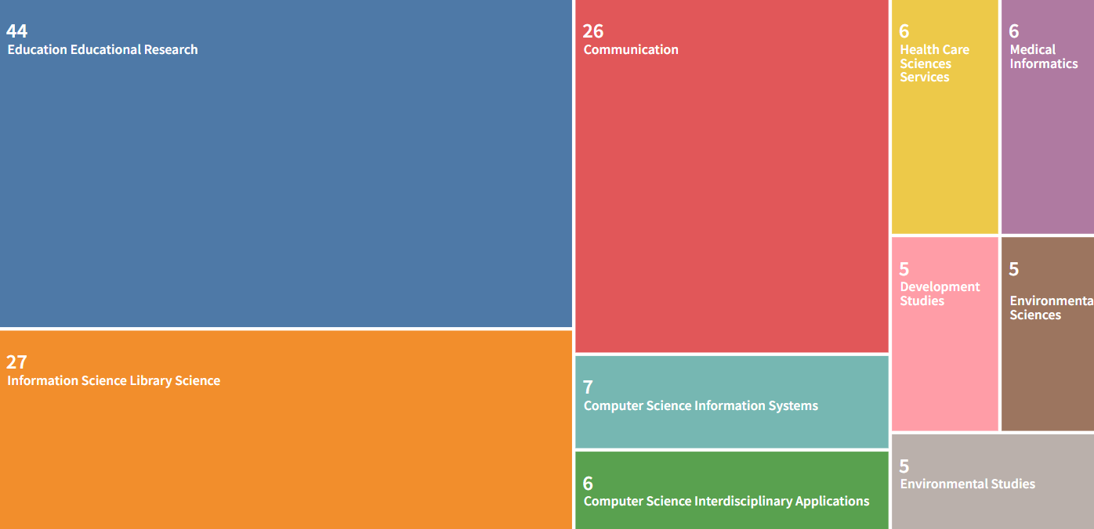

(*Web of Science Search Results* 2022).

Table 4. Taylor & Francis are the lead publishers addressing definitions and the digital divide.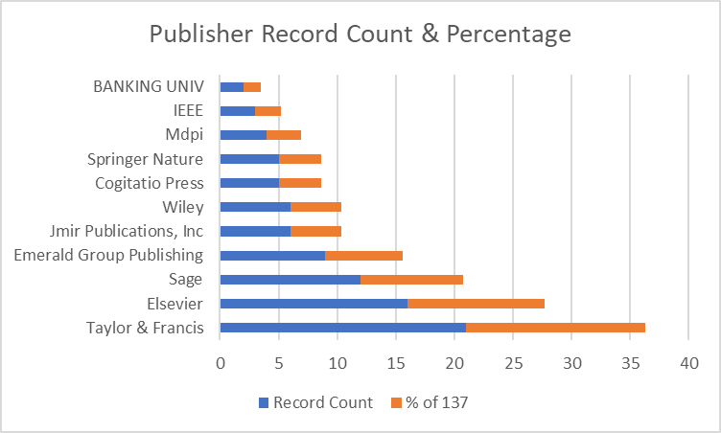

(*Web of Science Search Results* 2022).

The same approach was applied when searching for publications that included topics of *public libraries*, the *digital divide*, and *digital literacy* being searched within proximity of text. For consistency, the same Boolean operators and query strings were implemented to answer research questions R2 and R3, only instead of looking for *definitions*, the phrase *public libraries* was used instead. The topic terms needed to be located close to one another within the publications to deem relevance. Individual queries were searched, and then the strings of queries were finally combined to eliminate any duplications. The Web of Science Core Collection database returned 93 publications, of which 67 were produced from 2015 to 2022 (*see Table 4*). During the time frame in question, most publications were produced during the COVID-19 era after 2020. Therefore, scholars produced a little more than three times the number of articles in half the time, averaging 21.5 articles per year during the COVID-19 era. Between 2015-2019, scholars produced an average of only six articles per year. Taylor & Francis once again led the record count as publishers (*see Table 7*), but the Library and Information Science category dominated the record count of articles assigned (*see Table 6*).

Table 5. The number of publications public libraries in digital literacy and bridging the digital divide appearing between 2015 to 2019 and 2020 to 2022?

| **Operator** | **Role of Public Libraries in the Digital Divide & Digital Literacy** | **Total Items** | **2015-2022** | **2015-2019** | **2020-2022** |
| --- | --- | --- | --- | --- | --- |
| **AND** | ("public library" AND "digital divide") | 28 | 19 | 9 | 10 |
| **AND** | ("public library" AND "digital literacy") | 20 | 19 | 8 | 11 |
| **NEAR/x** | (public librar* NEAR/20 (digital NEAR/0 divide)) | 61 | 39 | 14 | 25 |
| **NEAR/x** | (public librar* NEAR/20 (digital NEAR/0 literacy)) | 33 | 31 | 11 | 20 |
| **NEAR/x**  **AND**  **AND** | (public librar* NEAR/20 (digital NEAR/0 divide) AND (public librar* NEAR/20 (digital NEAR/0 literacy))) | 4 | 4 | 0 | 4 |
| **NEAR/x**  **AND**  **OR** | (public librar* NEAR/20 (digital NEAR/0 divide) OR (public librar* NEAR/20 (digital NEAR/0 literacy))) | 90 | 66 | 23 | 43 |
| **ALL QUERIES**  **(combined** | (((((TS=(("public library" AND "digital divide"))) OR TS=(("public library" AND "digital literacy") )) OR TS=((public librar* NEAR/20 (digital NEAR/0 divide)))) OR TS=((public librar* NEAR/20 (digital NEAR/0 literacy)))) OR TS=((public librar* NEAR/20 (digital NEAR/0 divide) AND (public librar* NEAR/20 (digital NEAR/0 literacy))))) OR TS=((public librar* NEAR/20 (digital NEAR/0 divide) OR (public librar* NEAR/20 (digital NEAR/0 literacy)))) | 93 | 67 | 24 | 43 |

(*Web of Science Search Results* 2022).

Table 6. The LIS category leads in a record count of topic searches about public libraries, digital literacy, and the digital divide.

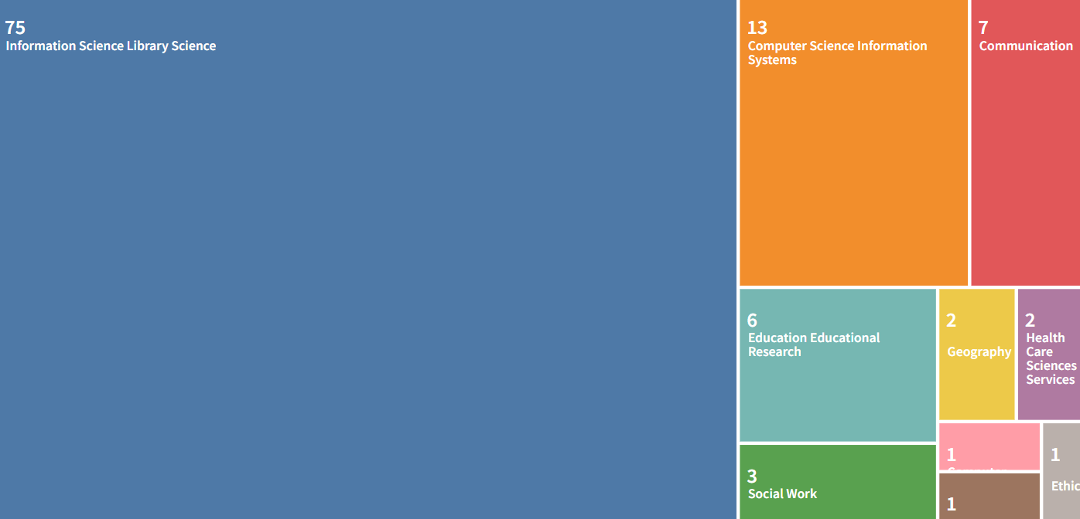

(*Web of Science Search Results* 2022).

Table 7. The record count for publishers shows Taylor & Francis as having the most publications about public libraries, the digital divide, and digital literacy.

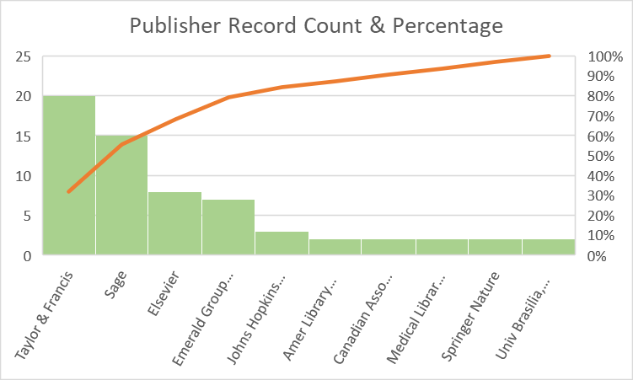

(*Web of Science Search Results* 2022).

# Discussion

On a global scale, the Web of Science Core Collection database has coverage that includes more than 21,858 journals. Its record count comprises 85 million records, more than 134,000 books, and 300,000 conferences. Given the scope of the collection, when searching *TS=("digital literacy")*, the database returns 2,202 records from 2015-2022. When searching *TS=("digital divide")*, the database returns 3,203 records from 2015-2022. Nevertheless, when searching for both topics, only 174 records appear within this same period. Two thousand three hundred seventy-four records appear from the *TS=(“public librar*”)* query string, but only 45 records appear from *TS=(“public librar*”) AND (“digital divide”)* within the same period. Only 34 records populate from the search *TS=(“public librar*”) AND (“digital literacy”)* from 2015 to 2022. These are only topic term searches; one could test searching in all fields, but how relevant would the results be? Considering the scope of the entire Web of Science Core Collection, how do so few record counts appear from such basic keyword strings? If interest in the digital divide was waning before 2020, the Covid-19 pandemic certainly changed minds and momentum about the digital divide. However, should it have taken a global pandemic to spark more conversations about who is or is not living without access to the information? Could public libraries perform their best in keeping communities up-to-date with digital media if there needed to be more research in the first place?

# Conclusion

Based on the findings in this study, scholars are either studying the digital divide or digital literacy, but not both in correlation. Though scholars acknowledge the importance of public libraries role in general, the significance of their roles in the digital divide is overlooked. There need to be more hands-on activities, interviews with patrons and library staff, surveying what type of motivation would ignite interest, and helping public libraries provide more awareness about the importance of the digital divide. The findings in this study showed that there needed to be more research on the role public libraries can play in bridging the digital divide. Thus it is no wonder that when the pandemic hit, public libraries encountered many of the challenges mentioned in this report. Increased funding can help libraries offer better resources and services.

Arguably, the digital divide is nothing short of a global crisis, and public libraries play a vital role in providing services that can bridge that divide in digital media access and ability. However, the public needs to be better aware of the digital divide. There should be more discussions and awareness about the gravity of being digitally illiterate. More so, the fact that the people who suffer most from the digital divide are the same people who suffer socioeconomically in other ways shows that there needs to be a more drastic intervention on behalf of the state and government officials. Internet service providers should not be allowed to discriminate against communities because of their demographics, and public libraries should be provided with the highest quality of Internet services and infrastructure made available to the public.

However, the ingenuity of public libraries should be commended when faced with limited resources. Public librarians tend to 'think on their feet to stay relevant to their communities, and using digital media can help libraries maintain their connection with their patrons. However, public libraries are not used to their full potential.

# Bibliography

Adkins, & Moulaison Sandy, H. (2020). Information behavior and ICT use of Latina immigrants to the U.S. Midwest. *Information Processing & Management, 57*(3). <https://doi-org.lynx.lib.usm.edu/10.1016/j.ipm.2019.102072>

Beyene, W. M. (2018). Digital inclusion in library context: A perspective from users with print disability. *Journal of Web Librarianship, 12*(2), 121–140. <https://doi.org/10.1080/19322909.2018.1427657>

Boeres, S. (2018). Literacy and Digital Information Attached to Lifelong Learning. *Revista Digital de Biblioteconomia e Ciencia Da Informacao, 16*(2), 483–500. <https://doi-org.lynx.lib.usm.edu/10.20396/rdbci.v16i2.8651507>

Borg, K., Boulet, M., Smith, L., & Bragge, P. (2019). Digital Inclusion & Health Communication: A Rapid Review of Literature. Health Communication, 34(11), 1320–1328. <https://doi-org.lynx.lib.usm.edu/10.1080/10410236.2018.1485077>

Butler, R. (2019). Health information seeking behaviour: the librarian’s role in supporting digital and health literacy. *Health Information & Libraries Journal, 36*(3), 278–282. <https://doi-org.lynx.lib.usm.edu/10.1111/hir.12278>

Campos-Castillo, C. (2014). Revisiting the first-level digital divide in the United States: Gender and race/ethnicity patterns, 2007–2012. *Social Science Computer Review, 33*(4), 423–439. <https://doi.org/10.1177/0894439314547617>

Clarivate. (2022, December 6). Web of Science Search Results. Retrieved December 6, 2022, from <https://www-webofscience-com.lynx.lib.usm.edu/wos/woscc/analyze-results/140023ac-285f-4588-97bc-363cb0d01efb-63ed95e7>

Crelin, J. (2021). Digital Divide: Overview. Points of View: Digital Divide, pp. 1–3.

Delello, J. A., & McWhorter, R. R. (2017). Reducing the digital divide: Connecting older adults to iPad technology. *Journal of Applied Gerontology, 36*(1), 3–28. <https://doi-org.lynx.lib.usm.edu/10.1177/0733464815589985>

Digital Literacy -- What Are We Really Talking About? (2016). *Collected Magazine*, 18, 21.

Dijk J. van. (2020). The digital divide. Polity Press.

Dolcini, M. M., Canchola, J. A., Catania, J. A., Song Mayeda, M. M., Dietz, E. L., Cotto-Negrón, C., & Narayanan, V. (2021). National-Level Disparities in Internet Access Among Low-Income and Black and Hispanic Youth: Current Population Survey. J*ournal of medical Internet research, 23*(10), e27723. <https://doi.org/10.2196/27723>

Federal Communications Commission. (2022, November 7). Recommendations and best practices to prevent digital discrimination ... *Communications Equity and Diversity Council*. Retrieved November 22, 2022, from <https://www.fcc.gov/sites/default/files/cedc-digital-discrimination-report-110722.pdf>

Fourie, I., & Meyer, A. (2016). Role of libraries in developing an informed and educated nation. *Library Hi Tech, 34*(3), 422–432. <https://doi-org.lynx.lib.usm.edu/10.1108/LHT-01-2016-0009>

Goedhart, N. S., Broerse, J. E. W., Kattouw, R., & Dedding, C. (2019). 'Just having a computer doesn't make sense': The digital divide from the perspective of mothers with a low socioeconomic position. *New Media & Society, 21*(11–12), 2347–2365. <https://doi-org.lynx.lib.usm.edu/10.1177/1461444819846059>

Grossman, L., Creber, R., Ancker, J., Grossman, L. V., Masterson Creber, R. M., Benda, N. C., Wright, D., Vawdrey, D. K., &amp; Ancker, J. S. (2019). Interventions to increase patient portal use in vulnerable populations: a systematic review. *Journal of the American Medical Informatics Association : JAMIA., 26*(8-9), 855–870. <https://doi.org/10.1093/jamia/ocz023>

Hall, T. D. (2021). Information Redlining: The Urgency to Close the Digital Access and Literacy Divide and the Role of Libraries as Lead Interveners. J*ournal of Library Administration, 61*(4), 484–492. <https://doi-org.lynx.lib.usm.edu/10.1080/01930826.2021.1906559>

Hallam, G., Thomas, A., & Beach, B. (2018). Creating a Connected Future Through Information and Digital Literacy: Strategic Directions at The University of Queensland Library. *Journal of the Australian Library & Information Association, 67*(1), 42–54. <https://doi-org.lynx.lib.usm.edu/10.1080/24750158.2018.1426365>

Han, S., & Nam, S. I. (2021). Creating supportive environments and enhancing personal perception to bridge the digital divide among older adults. *Educational Gerontology, 47*(8), 339–352. <https://doi-org.lynx.lib.usm.edu/10.1080/03601277.2021.1988448>

Hernández-Pedreño, M., Romero-Sánchez, E., &amp; Gómez-Hernández, J.-A. (2019). Las Bibliotecas Públicas Ante La Inclusión Digital: Desafíos para una ciudadanía más igualitaria. *Revista Mediterránea De Comunicación, 10*(1), 41. <https://doi.org/10.14198/medcom2019.10.1.12>

Kruger L. G. Gilroy A. A. & Library of Congress. (n.d.). Broadband Internet access and the Digital divide: federal assistance programs. Retrieved November 9 2022 from <https://purl.fdlp.gov/GPO/gpo111174>

Landers, C. S. (2017). The Digital Divide : Issues, Recommendations and Research. Nova Science Publishers, Inc.

Maceviciute, E., &amp; D. Wilson, T. (2018). Digital means for reducing digital inequality: Literature review. *Informing Science: The International Journal of an Emerging Transdiscipline, 21*, 269–287. <https://doi.org/10.28945/4117>

Neves, B. B., Waycott, J., & Malta, S. (2018). Old and afraid of new communication technologies? Reconceptualising and contesting the ‘age-based digital divide.’ *Journal of Sociology, 54*(2), 236–248. <https://doi-org.lynx.lib.usm.edu/10.1177/1440783318766119>

Muschert, G. W., &amp; Ragnedda, M. (2015). *The digital divide: The Internet and social inequality in international perspective*. Routledge.

Nguyen, M. H., Hargittai, E., & Marler, W. (2021). Digital inequality in communication during a time of physical distancing: The case of COVID-19. *Computers in human behavior, 120*, 106717. <https://doi.org/10.1016/j.chb.2021.106717>

Pressgrove, J. (2022). Make Me a Map: Plotting progress requires a well-defined starting point. Here’s how cities and states are identifying the areas with the greatest need for connectivity. *Government Technology, 35*(2), 22–27.

Rachfal, C. L., &amp; Gilroy, A. [Report], The digital divide: What is it, where is it, and federal assistance programs (2021). *Congressional Research Service*. Retrieved November 9 2022 from <https://purl.fdlp.gov/GPO/gpo154145>

Real, B., Bertot, J. C., & Jaeger, P. T. (2014). Rural Public Libraries and Digital Inclusion: Issues and Challenges. *Information Technology & Libraries, 33*(1), 6–24. <https://doi-org.lynx.lib.usm.edu/10.6017/ital.v33i1.5141>

Real, Brian. 2021. “Bridging Digital Divides during COVID-19: Findings from the 2020-2021 Connecticut State Library Digital Inclusion Survey.” *Public Library Quarterly 40*(4): 283–309. doi:10.1080/01616846.2021.1938918.

Reynolds, R. (2020). Janvandijk. (2020). the digital divide. Cambridge, UK: Polity, 208 pp. £17.99 (paperback) (ISBN 9781509534456). *Journal of the Association for Information Science and Technology, 72*(1), 136–138. <https://doi.org/10.1002/asi.24355>

Rhinesmith, C., Reisdorf, B., & Bishop, M. (2019). The ability to pay for broadband. *Communication Research & Practice, 5*(2), 121–138. <https://doi-org.lynx.lib.usm.edu/10.1080/22041451.2019.1601491>

Rhinesmith, Krongelb, M., & Jiang, J. (2022). The Digital Equity Leadership Lab (DELL). *The Journal of Community Informatics., 18*(1), 104–131. <https://doi-org.lynx.lib.usm.edu/10.15353/joci.v18i1.4875>

Ritzo, C., Rhinesmith, C., &amp; Jiang, J. (2022). Measuring Library Broadband Networks to address knowledge gaps and data caps. *Information Technology and Libraries, 41*(3). <https://doi.org/10.6017/ital.v41i3.13775>.

Szalusky. (2021, September 14). *National Survey finds libraries play an expanded role in Digital Equity, bridging gaps in access to technology.* News and Press Center. Retrieved December 5, 2022, from <https://www.ala.org/news/press-releases/2021/08/national-survey-finds-libraries-play-expanded-role-digital-equity-bridging>

Scheerder, A., van Deursen, A., & van Dijk, J. (2017). Determinants of Internet skills, uses and outcomes. A systematic review of the second-and third-level digital divide. *Telematics & Informatics, 34*(8), 1607–1624. <https://doi-org.lynx.lib.usm.edu/10.1016/j.tele.2017.07.007>

Scorse, Y., &amp; Tesfaye, T. (2022, August 29). Definitions. *National Digital Inclusion Alliance*. Retrieved November 14, 2022, from <https://www.digitalinclusion.org/definitions/>

Seifert, A. (2020). The Digital Exclusion of Older Adults during the COVID-19 Pandemic. *Journal of Gerontological Social Work, 63*(6/7), 674–676. <https://doi-org.lynx.lib.usm.edu/10.1080/01634372.2020.1764687>

Stevenson, S. (2009). Digital Divide: A Discursive Move Away from the Real Inequities. *Information Society, 25*(1), 1–22. <https://doi-org.lynx.lib.usm.edu/10.1080/01972240802587539>

Strover, S. (2019). Public libraries and 21st century digital equity goals. *Communication Research & Practice, 5*(2), 188–205. <https://doi-org.lynx.lib.usm.edu/10.1080/22041451.2019.1601487>

Tracy, D.G. (2016). Assessing Digital Humanities Tools: Use of Scalar at a Research University. portal: *Libraries and the Academy 16*(1), 163-189. doi:10.1353/pla.2016.0004.

van Deursen, A. J. A. M., &amp; van Dijk, J. A. G. M. (2013). The digital divide shifts to differences in usage. *New Media &amp; Society, 16*(3), 507–526. <https://doi.org/10.1177/1461444813487959>

van Laar, van Deursen, A. J., van Dijk, J. A., & de Haan, J. (2017). The relation between 21st-century skills and digital skills: A systematic literature review. *Computers in Human Behavior., 72*, 577–588. <https://doi-org.lynx.lib.usm.edu/10.1016/j.chb.2017.03.010>

Xie, B., Charness, N., Fingerman, K., Kaye, J., Kim, M. T., &amp; Khurshid, A. (2020). When going digital becomes a necessity: Ensuring older adults’ needs for information, services, and Social Inclusion during COVID-19. *Journal of Aging &amp; Social Policy, 32*(4-5), 460–470. <https://doi.org/10.1080/08959420.2020.1771237>